|  |
| --- |
|  |
| Quick Zone Simulation Problem |
| CS1538: Introduction to Simulation |

|  |
| --- |
| Mark Shanoudy, Steven Ross, & Jeremy McCandlish  12-10-2014 |

# Introduction

We decided to model Quick Zone which is located in the base of the Towers complex. We attempted to simulate the real life environment by collecting observable data and implementing the system in Java. The actual location was interesting to us for multiple reasons. First, the central location on campus provides access to a service that the average student or faculty member has used during their time at the University of Pittsburgh. Next, the two types of services at the location provide a challenge in modeling the actual system and improving it while keeping the assumptions we make valid in relation to the real world environment. The location in particular contains a convenience store and a take-out food hub, known as Market-To-Go. Customers that are finished with either service bottleneck at the cashiers before they exit. Finally, Quick Zone provides a subject that follows the distributions—Poisson, and Normal—and Queuing models that we focused on in our class. The main problem that we are trying to solve by implementing this simulation is to decrease customer wait times and keep cashier occupation time (busy time) to approximately 50% or higher. We tested different cashier configurations and found that when you increase the number of cashiers past two during a normal day there isn’t a significant difference in customer wait times. However, when cashier numbers are increased past two cashiers, the occupation percentage falls to an unacceptable level.

# Background

Quick Zone has several measurable variables that contribute to how the system runs. Until recently, Market-To-Go was located across the lobby in Towers’ basement. The University expanded the main dining area, Market, to accommodate the influx of new Pitt students which in turn caused the original Market-To-Go location to be taken over. Market-To-Go now resides in the location that used to belong to a Taco Bell. Market-To-Go is now a part of Quick Zone.

The main service area acts as a queueing model with an infinite server capacity as each customer serves themselves. Market-To-Go has a different setup entirely. There are different stations with premade food items and a take-out area. The take-out area is the main focus for the Market-To-Go portion of our simulation. The order area is serviced by one employee in the current real environment. A queue forms up at this point with one customer being serviced at a time. The customer has the option of picking two sides and one main item. The sides are usually consistent on a day to day basis with mac-and-cheese, mashed potatoes, or corn being examples. Once the customers are finished in either the Market To-Go area or the Quick Zone area, they proceed to the checkout location that is located at the entrance of Quick Zone. The checkout location has space for four active cashiers (servers) with queues forming at their relative location. The real life environment system usually only has one or two of the checkout locations open at a time. The customers form queues at each checkout location with the customer usually choosing the queue with the least amount of customers in it.

# Approach/Method

Data Collection

Data was collected by directly observing customers at Quick Zone. Arrival times to Quick Zone (QAT), arrival times to the cashier (CAT), and system exit times (QET) were recorded for sixty customers on Friday, December 5th from 8:00pm―9:00pm. From the aforementioned variables, we were able to calculate the Quick Zone item selection time (QST) by subtracting QAT from CAT. The cashier service time (CST) was calculated by subtracting CAT from QET. The arrival rate was recorded separately by logging both the number of customers arriving at any given time and at what time they arrived. The number of items being purchased by thirty-six individual customers was also observed—although not used in the final model. Finally, we detailed the ratio of customers who shopped at Market-To-Go vs. those who shopped at the convenience store portion of Quick Zone only.

Input Modelling

There were three main distributions that were calculated: arrival rate, Quick Zone service time (item selection time for people shopping in the convenience portion of Quick Zone), and cashier service time.

For arrival rate, we began by separating the groups of simultaneous arrivals by one second each. Then we generated histograms for one, five, and ten minute intervals of which the minute interval is shown below.

The mean of each frequency interval was then calculated, which equaled 35.17, 17.58, and 3.52 for ten minutes, five minutes, and one minutes respectively. It was hypothesized that the arrival rate would fit a Poisson distribution.

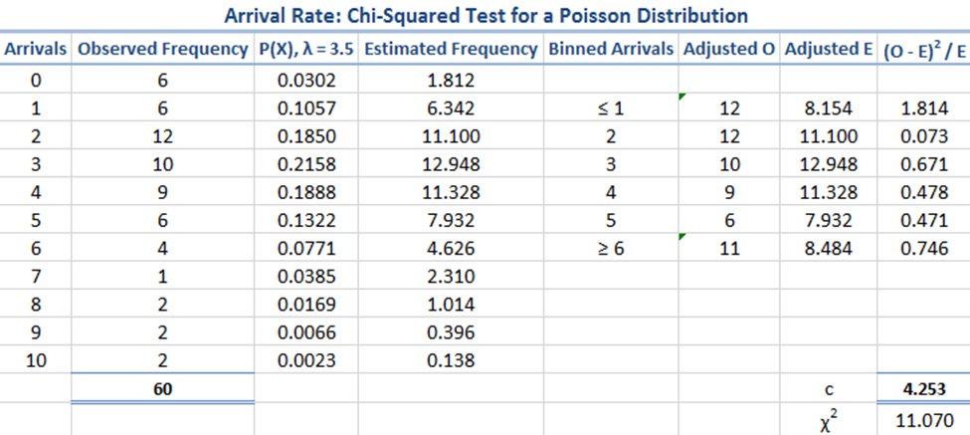The critical value was found to be 4.523. The Pearson test statistic at five degrees of freedom is 11.070. Since c > χ2 we do not reject the null hypothesis. In order to further check the fit of the data to the Poisson distribution, a distribution fit test was run in Mathematica which confirmed that the null hypothesis is not rejected at the 5% level based on the Pearson χ2 test.

The Quick Zone service time was hypothesized to follow a Normal distribution. We generated a histogram of the data in ten second intervals in order to get a general idea of the distribution.

The data was then run through Mathematica using a distribution fit test. The test showed that the null hypothesis that the data is distributed according to the NormalDistribution[97.7833, 79.7998] is not rejected at the 5 percent level based on the Cramér-von Mises test.

For the cashier service time, we hypothesized that it would also follow a Normal distribution. The calculated μ equaled 15.35 seconds and σ equaled 12.97 seconds. A histogram was then generated using five second intervals.

The data was then run through Mathematica using a distribution fit test. The test showed that the null hypothesis that the data is distributed according to the NormalDistribution[15.35, 12.9652] is rejected at the 5 percent level based on the Cramér-von Mises test. We then hypothesized that the data could be Exponentially distributed. The test showed that the null hypothesis that the data is distributed according to the ExponentialDistribution[0.0651466] is rejected at the 5 percent level based on the Cramér-von Mises test. At this point, we removed data points that were outside of one standard deviation to eliminate any outliers that could be skewing our data. The new µ equaled 12.02 seconds and σ equaled 5.69 seconds. We then tested for Normal distribution again using the new data set. The test showed that the null hypothesis that the data is distributed according to the NormalDistribution[12.0189, 5.68565] is not rejected at the 5 percent level based on the Cramér-von Mises test.

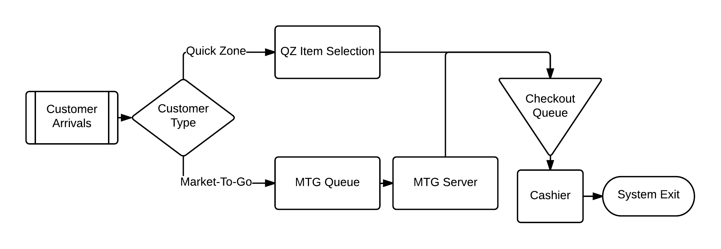The Model

Our model is a queue comprised of three sub sections. The customer arrival list, which contains the customer arrival time (CAT), customer ID, and the customer type, is preprocessed at the beginning of the simulation for all customers. Customers are then split into two different lists—one for customers who be shopping in the Quick Zone convenience area (QZ) and the other for customers who will be ordering Market-To-Go (MTG). The QZ customers will have their item selection time calculated. The MTG customers will enter the MTG queue. If the queue is empty, they will proceed directly to the MTG server with no wait time to have their order filled. Both sets of customers will then merge at the checkout queue. After being processed by the cashier, customers exit the system.

Assumptions and Simplifications

We assume that people who arrive at the same time are actually separated by a unit of time smaller than our base unit of seconds. It is assumed that a customer will always purchase something if they enter the system. It is assumed that the system has unlimited capacity. It is assumed that in the presence of multiple servers or cashiers, customers will always choose the queue with the shorter wait time. There were also several simplifications that were made involving how the system works. MTG servers have a constant service time of thirty seconds. This simplification was made due to the fact we did not have the opportunity to adequately record data on service times. Likewise, item selection time for MTG customers is uniformly distributed with a range of thirty to one hundred and eighty seconds. Because of time constraints, customers entering the system are assigned to either QZ or MTG but not both. Furthermore, employees of Quick Zone have been simplified so that they do not take breaks. Item count is also not taken into consideration because we felt our sample size was too small to calculate an accurate distribution.

# Experimental Setup

The first experiment performed was comparing a simulation of a typical weekday at Quick Zone with different cashier configurations. The goal of this experiment is to see which configuration has the lowest customer wait times while keeping cashiers occupied for the maximum percent of time possible. We hypothesized that as the number of cashiers is increased, the queue wait times would decrease. Furthermore, it was expected that as the number of cashiers is increased, the idle time of each cashier would also increase. It was, however, unknown how much of an increase in idle time would be observed.

Four different configurations were tested. Each configuration had a different number of cashiers, one through four, while having one constant MTG server. We used the same seed for the random generator in order keep all variables the same across all trials except for the variables we were testing, such as the number of cashiers. Furthermore, we used the first configuration of one cashier as the baseline for comparison to the other configurations. Below are our results.

|  |  |  |  |
| --- | --- | --- | --- |
|  | **Average Cashier Queue Wait Time** | | |
|  | **Total** | **QZ** | **MTG** |
| 1 | 1691.79 | 1431.96 | 2613.93 |
| 2 | 2.65 | 2.73 | 2.36 |
| 3 | 0.38 | 0.40 | 0.32 |
| 4 | 0.07 | 0.08 | 0.05 |

|  |  |  |  |  |
| --- | --- | --- | --- | --- |
|  | **Average Cashier Queue Wait Time** | | | |
|  | **Cashier 0** | **Cashier 1** | **Cashier 2** | **Cashier 3** |
| 1 | 1691.79 |  |  |  |
| 2 | 2.71 | 2.60 |  |  |
| 3 | 0.43 | 0.37 | 0.35 |  |
| 4 | 0.11 | 0.05 | 0.05 | 0.07 |

|  |  |  |  |  |
| --- | --- | --- | --- | --- |
|  | **Occupied %** | | | |
|  | **Cashier 0** | **Cashier 1** | **Cashier 2** | **Cashier 3** |
| 1 | 87% |  |  |  |
| 2 | 44% | 43% |  |  |
| 3 | 29% | 29% | 29% |  |
| 4 | 22% | 22% | 22% | 22% |

The results showed that our hypothesis was correct. In regard to which configuration was the best in terms of wait time reduction, configuration four was the best. However, after two cashiers, the difference was negligible. As far as percent of time occupied vs. average customer wait time, configuration two offered the best customer wait times while having cashiers idle for the least amount of time.

Our second experiment was similar to the first with the difference of comparing the simulation of a single hour during peak times instead of an entire work day. Below are the results.

|  |  |  |  |
| --- | --- | --- | --- |
|  | **Average Cashier Queue Wait Time** | | |
|  | **Total** | **QZ** | **MTG** |
| 1 | 653.15 | 645.75 | 155.65 |
| 2 | 3.69 | 3.98 | 155.65 |
| 3 | 0.59 | 0.67 | 155.65 |
| 4 | 0.11 | 0.10 | 155.65 |

|  |  |  |  |  |
| --- | --- | --- | --- | --- |
|  | **Average Cashier Queue Wait Time** | | | |
|  | **Cashier 0** | **Cashier 1** | **Cashier 2** | **Cashier 3** |
| 1 | 653.15 |  |  |  |
| 2 | 3.75 | 3.63 |  |  |
| 3 | 0.69 | 0.63 | 0.44 |  |
| 4 | 0.04 | 0.02 | 0.10 | 0.02 |

|  |  |  |  |  |
| --- | --- | --- | --- | --- |
|  | **Occupied %** | | | |
|  | **Cashier 0** | **Cashier 1** | **Cashier 2** | **Cashier 3** |
| 1 | 100% |  |  |  |
| 2 | 71% | 68% |  |  |
| 3 | 48% | 46% | 45% |  |
| 4 | 36% | 34% | 36% | 32% |

The results are similar to that of experiment one as expected. Wait times after two cashiers once again are close to zero. However, the idle time of cashiers in configurations with more than two cashiers is over 50%. Therefore, configuration two seems to be the best option with configuration three being close to the acceptable idle time of 50%.

# Conclusion

After running our simulation with a variety of experiments, we believe that the right server configuration can keep a low customer wait time while keeping the servers occupied to max amount of time. The server configuration with the best decrease in wait from the baseline was having four servers but it also drop the server occupied percentage to an unreasonable level. When there is only one server, the occupied time is at an acceptable level but at the expense of a large increase in wait times. Based off of the peak time experiment results, the best solution would be to have 3 servers at the Cashier check out area during the high traffic times--lunch and dinner. Due to time constraints, we were not able to reliably check the effect of adding more servers to the MTG server area. In the future, we would have liked to run a set of experiments that accounted for the extra servers in this area and see if it made any noticeable difference on the overall throughput of the whole location. Another variable we would have liked to have kept track of was the monetary aspect of the whole store. Due to time constraints and lack of information on the price at which the store bought the goods at cost along with employee wages, we were not able to reliably account for these variables in our system and run experiments on them.